**Introduction:**

Suppose you are a member of a manufacturer or semiconductor company, tasked with designing their new products or IC Chips which needs a lot of CAE (Computer Aided Engineering) or EDA (Electronic Design Automation) simulation. You do not have sufficient capacity on premises for this project and so will be using Azure for those HPC simulation needs. Management would like this project to be completed in a timely and cost-effective manner. You choose Azure NetApp Files (ANF) as the back-end storage solution as it provides an on-premises-like experience and performance. You will need to figure out the most optimal and cost-effective way of building and running your HPC applications in Azure.

In this module, you will learn how to choose proper ANF service level and volume quota for your HPC applications, create and configure ANF and mount an ANF volume from Virtual Machines, and some practical performance tuning practice.

* **Learning objectives**
  + **Learn how to choose proper tier and volume size when running your HPC applications on Azure NetApp Files.**
  + **Learn how to create and configure ANF, and mount an ANF volume.**
  + **Learn practical performance tuning practice.**
* **Prerequisites**
  + Can deploy virtual machines (VM) in Azure.

**Next unit: Understand ANF’s storage hierarchy.**

**Understand ANF’s storage hierarchy.**

* 5 minutes

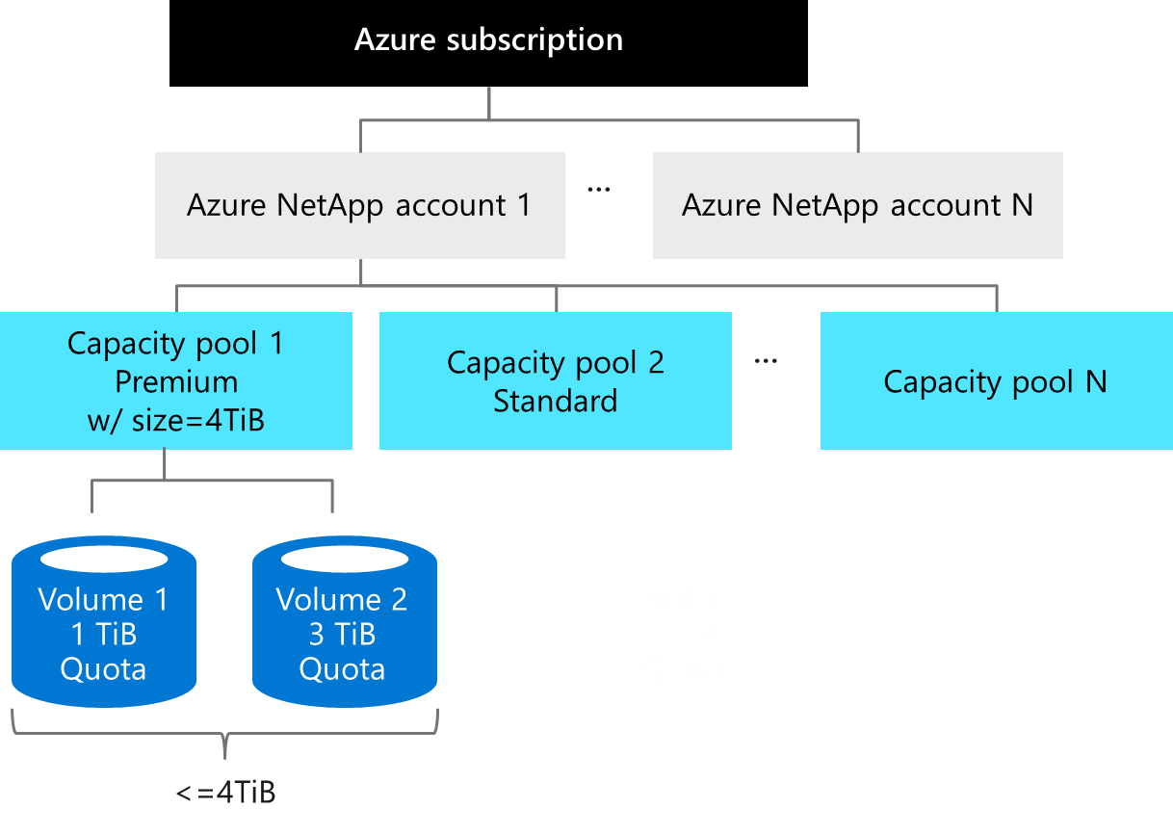

1) Azure NetApp Files account is primarily an administrative concept and is in regional scope. You will need to create an ANF account first.

2) Then you will need to create Capacity Pools under your ANF account. A single ANF account can have up to 25 Pools. The provisioned size of each Pool can then be assigned to Volumes within it. In this example we provisioned 4TB to Capacity Pool 1. This Pool is also assigned a “Premium” ANF service level, which we'll discuss in next section. Please note that ANF is charged based on the provisioned size of Capacity Pools. Size of Pools can vary from 4TB to 500TB each.

3) Volumes are the actual constructs which will be mounted from your VM(s) and being consumed. They're assigned a quota limit, which can range from 100GB to 100TB, and the total Volume capacity cannot exceed the provision size of the Capacity Pool. In this example, there are 2 Volumes within Capacity Pool 1 and the total quota limit cannot exceed 4TiB. All Volumes in a Pool will have the same service level, Premium in this example.

**Next unit: Understand ANF performance regarding to service level and volume quota.**

**Understand ANF performance regarding to service level and volume quota.**

* 5 minutes

ANF performance, respecting to throughput, is simple to design and easy to configure. As illustrated in below figure, there are TWO key factors involved: the 1st is Service Level, which establishes the baseline level of performance, and the 2nd is the Volume quota. You get the gross performance limit of the Volume by multiplying the two factors.

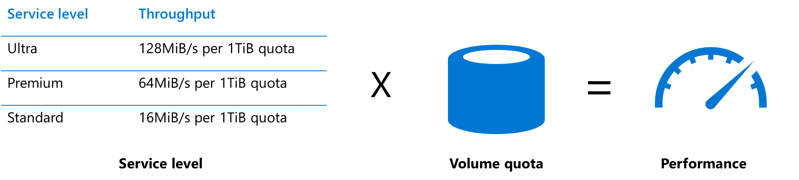

For example:

* If you choose Premium as Service level, you will get 64MiB/sec for every 1TiB of quota within the Volume.
* You provision a Volume with a 10TB quota, then that Volume can deliver up to 64*10=640MiB/sec of throughput.

Please note that the gross throughput is set by the quota of the Volume, not the actual capacity consumed in the Volume.

Also, you can increase or decrease the quota of your Volume in anytime, and it will affect the performance behavior virtually instantly. You do not need to reboot your VM nor to re-mount your Volume.

How do you know the needed bandwidth of throughput? If you know both the IOPS and the transfer size of your workload, you can calculate the bandwidth required by multiplying them together. For example, if your workloads need 100,000 IOPS and have an averaged transfer size of 16KB, then the bandwidth required is 1.53 GB per second. Based on this, you will be able to choose proper Service Level and Volume quota.

100,000 IOPS * 16KB = 1,600,000 KB/s = 1.53 GB/s

It's important to keep in mind that in real-world, storage performance is impacted by a wide range of factors, including the Read/Write mix, block size mix, and access patterns like random or sequential access.

**Knowledge Check**

* 3 minutes

Choose the best response for each question. Then select **Check your answers**.

**Check your knowledge.**

Top of Form

1.  What’s the top-down order of Azure NetApp Files storage hierarchy:

ANF Account -> ANF Container -> Volume

Capacity Pool -> ANF Account -> Volume

ANF Account -> Capacity Pool -> Volume

ANF Account -> Capacity Pool -> Storage Target

2. Your HPC applications need at least 50TiB size of file storage, and you would like to ensure 3,000MiB/sec in throughput. With below knowledge, which of the following ANF Service Level and volume quota would you choose?

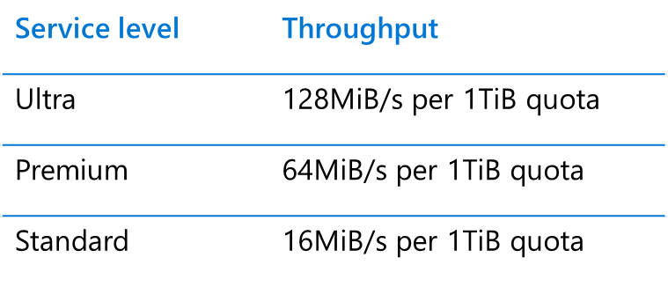

Ultra + 25TiB

Premium + 50TiB

Standard + 100Tib

None of above is feasible.

All above are feasible.

3. You would like to resize your ANF Volume size to reflect different HPC applications’ performance requirements, you need to perform below actions to make those change effective:

umount and mount the Volumes.

Reboot all VMs connecting to Volumes.

None of above, ANF will just affect performance change almost immediately.

Check your answers.

**Next unit: [Hands-on] Create an ANF Volume**

**[Hands-on] Create an ANF Volume**

Please follow below tutorial to create an ANF account, a 4TiB Premium Capacity pool, and a 4TiB Volume.

[Create a NetApp account for Access Azure NetApp Files | Microsoft Docs](https://docs.microsoft.com/en-us/azure/azure-netapp-files/azure-netapp-files-create-netapp-account)

[Set up a capacity pool for Azure NetApp Files | Microsoft Docs](https://docs.microsoft.com/en-us/azure/azure-netapp-files/azure-netapp-files-set-up-capacity-pool)

Your ANF hierarchy will be like below:

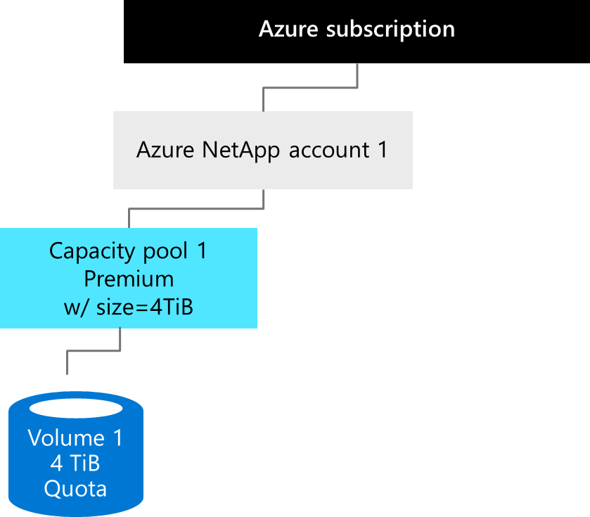

After you successfully created an ANF Volume, please follow [Mount Azure NetApp Files volumes for virtual machines | Microsoft Docs](https://docs.microsoft.com/bs-latn-ba/azure/azure-netapp-files/azure-netapp-files-mount-unmount-volumes-for-virtual-machines) to mount the Volume from a VM. ANF supports NFS 3.0, NFS 4.1 and SMB 3.1 protocols.

If the data consumed in your Volume exceeds the quota, 4TB in this example, ANF will not reject writes. This is the principle that ANF will try to avoid any data loss and data corruption. The pool size will increase incrementally until Pool size is greater than your consumed size. And that is the reason your will see df -h is showing 100TB in size all the time, as 100TB is the maximum Pool size allowed.

$ df -h

Filesystem Size Used Avail Use% Mounted on

x.x.x.x:/anfvol1 100T 0 100T 0% /anfvol1

**Next unit: ANF Scalability**

**ANF Scalability**

In real world, HPC workloads like EDA are running on hundreds or thousands of nodes (VMs) connecting to the same storage server. And it’s critical that the storage server can scale properly and still perform well when workloads increase.

The[SPEC SFS® 2014 benchmark](https://www.spec.org/sfs2014/) suite provides a standardized method to measure file server throughput and response time. It simulates real-world workloads including Database, EDA, Software Builds, VDA Streaming, and Desktop VDI scenarios.

Below the test results of EDA scenario:

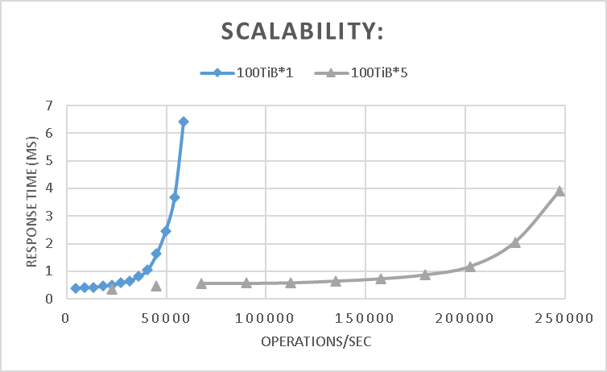

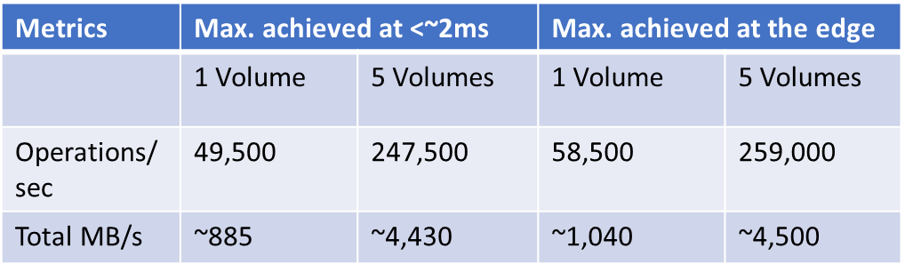

You can see that by simply adding # of Volumes to ANF, maximum throughput can scale linearly, and still maintaining low response time. (~500% from 1 to 5 volumes)

**Next unit: Performance tips (actimeo and nocto)**

**Performance tips (actimeo and nocto)**

Beginning from this Unit, some general practice to improve performance including ANF will be discussed.

**actimeo**

For applications that use grids of clients like EDA, web hosting and movie rendering and have relatively static data sets, there will have many getattr/access calls coming back to storage during the run. In these cases, there is a known lag in picking up new content and the application still works with potentially out of date data. For those scenarios, nocto and actimeo can be used to control the time period where out of data date can be managed.

For example, in EDA with tools and libraries and other static content, actimeo=600 works well because this data is typically updated infrequently. Using this mount options reduce the workload to storage significantly in these cases. A recent EDA experience reduced IOPS to the tool volume from >150K to ~6K and latency cut in half from ~2.08ms to ~1.05ms. It also reduced overall CPU% and load on the ANF nodes, and applications can run significantly faster.

The downside of setting the actimeo value too high is that attributes that change might not be reflected properly until the cache timeout occurs, which could result in unpredictable access issues.

**nocto**

The nocto option is used primarily to increase raw performance. For example, in the same vdbench tests run, the nocto mount option reduced latency by an additional 0.35ms to 0.7ms.

The recommendation for use of the nocto option is to use only with read-heavy/read-mostly workloads.

The charts below show latency reduced from ~2.08ms with default settings, to ~1.05ms with ‘actimeo=60’, and to ~0.7ms with both ‘actimeo=600,nocto’.

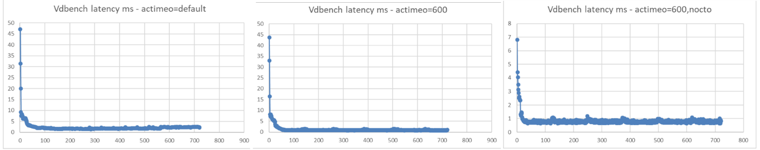

REFERENCE: [TR-4067: NFS in NetApp ONTAP Best Practice and Implementation Guide](https://www.netapp.com/media/10720-tr-4067.pdf)

**Next unit: Performance tips (sysctl)**

**Performance tips (sysctl)**

sysctl is used to modify kernel parameters at runtime. You can use sysctl to both read and write sysctl data. Well-tuning sysctl can help improve overall performance. Below the example implemented on Azure Ev4/Dv4 VMs.

$ sudo vi /etc/sysctl.conf

// Add or modify below attributes:

net.core.somaxconn = 65536

net.core.netdev_max_backlog = 300000

net.core.rmem_default = 67108864

net.core.wmem_default = 67108864

net.core.rmem_max = 67108864

net.core.wmem_max = 67108864

net.ipv4.tcp_rmem = 8192 87380 16777216

net.ipv4.tcp_wmem = 8192 87380 16777216

net.ipv4.tcp_fin_timeout = 5

//

$ sudo sysctl -p

REFERENCE: [sysctl - ArchWiki (archlinux.org)](https://wiki.archlinux.org/index.php/sysctl)

**Next unit: Performance tips (nconnect)**

**Performance tips (nconnect)**

**“nconnect”**, included in Linux kernel versions >= 5.3, is a feature that enables multiple TCP connections for a single NFS mount. Setting “nconnect” as a mount option enables the NFS client to open multiple “transport connections” for the same host and can boost performance in many HPC scenarios.

You can use uname -r to check Linux kernel version. Below the example to upgrade your VMs to the latest version of Linux kernel. Please note that you will need to reboot the VM at the end of the upgrade. So it might not be applicable for some cases.

# CentOS/Redhat 7+

$ sudo rpm -Uvh <http://www.elrepo.org/elrepo-release-7.0-2.el7.elrepo.noarch.rpm>

# CenOS/Redhat 8+

$ sudo rpm --import https://www.elrepo.org/RPM-GPG-KEY-elrepo.org

$ sudo yum -y --enablerepo=elrepo-kernel install kernel-ml

$ sudo reboot

$ sudo mount -t nfs -o rw,**nconnect=16**,nocto,actimeo=600, x.x.x.x:/vol1 /anfvol

**Next unit: Performance tips (conclusion)**

**Performance tips (conclusion)**

First let’s examine the effectiveness of the 3 options we have discussed in previous units.

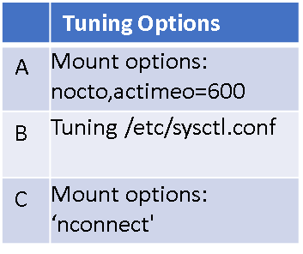

1. Below the FIO IOPS and Bandwidth test on random and sequential reads/writes. You can see those options all boost performance and the effectiveness can be added up.

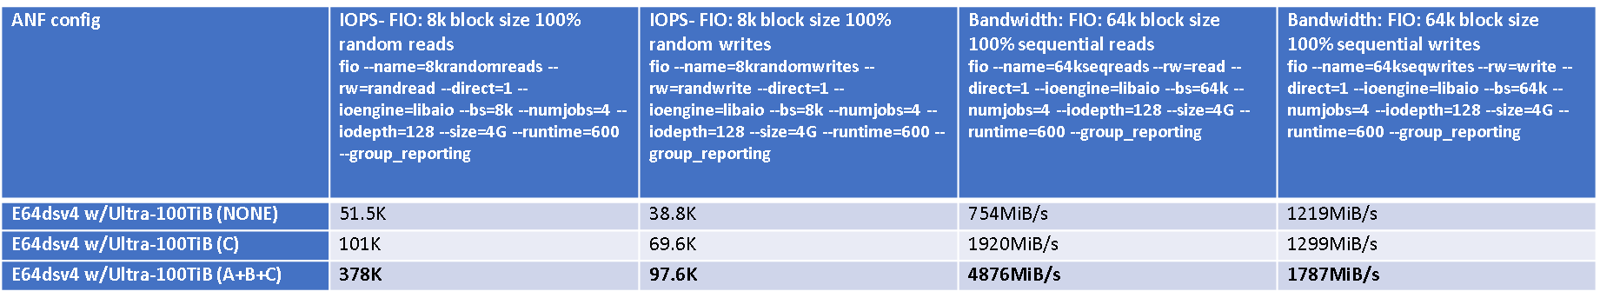

1. Below the EDA workload benchmark results applying the three options, you can see overall throughput improved significantly while maintaining low response time.

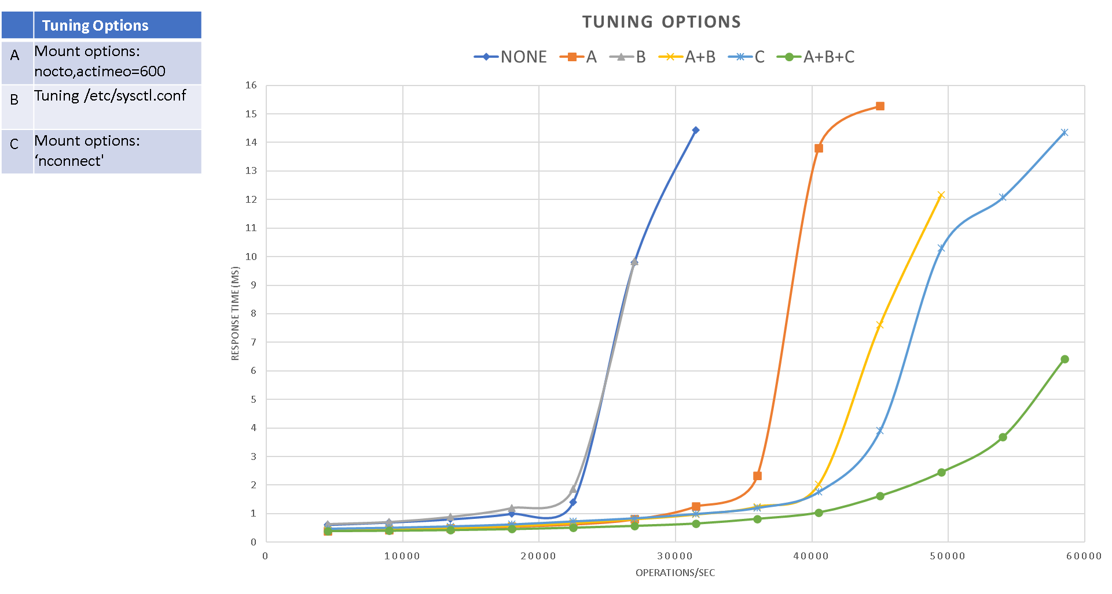

Other than the three options discussed above, below charts examine several other characteristics, including NFS version, TCP/UDP and MTU size, using the same EDA benchmarking tools.

NFS 4.1 shows poor performance compared to NFS 3, so be cautious on using 4.1 if there’s no specific security requirements. TCP performs slightly better than UDP, and no significant impact with MTU size of client VM.

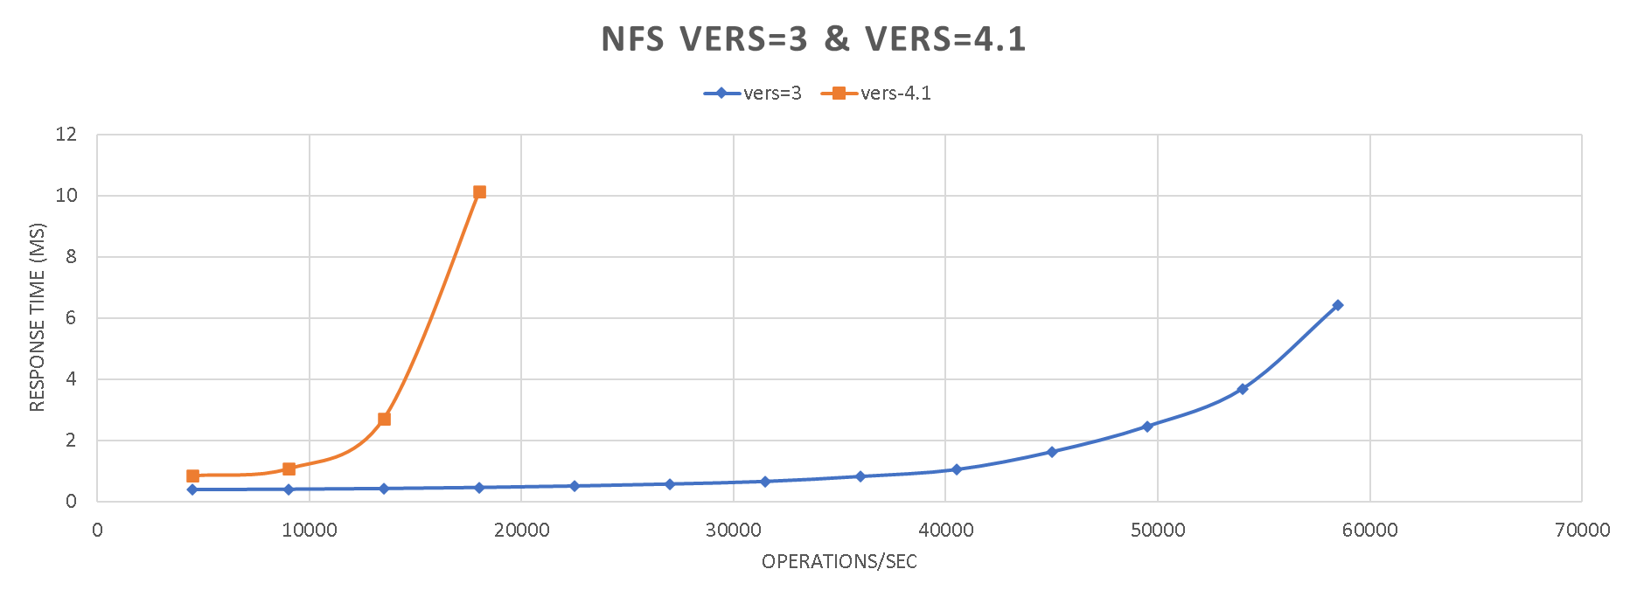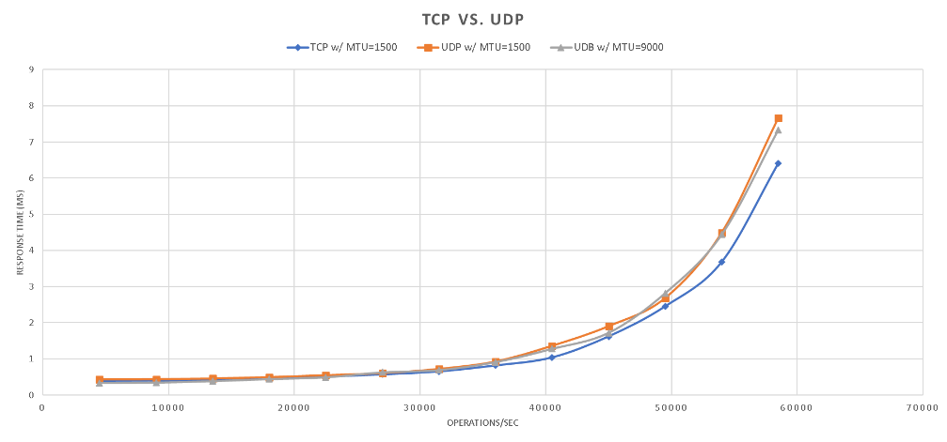

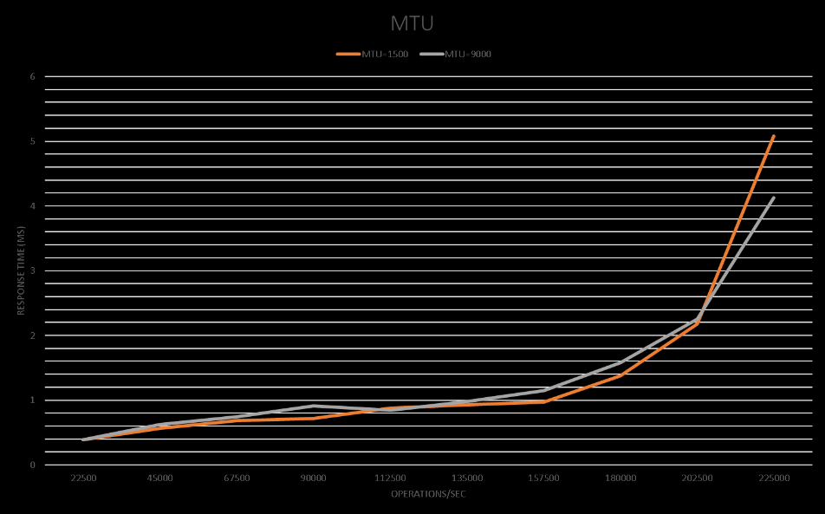

**Knowledge Check**

* 3 minutes

Choose the best response for each question. Then select **Check your answers**.

**Check your knowledge.**

Top of Form

1.  Check the option(s) which can improve overall performance when running EDA applications on ANF:

Use ‘nconnect’ mount options.

Use NFS 4.1 instead of NFS 3.0

Use ‘actimeo and nocto’ mount options.

Fine-tune value of rsize and wsize.

Fine-tune sysctl.

Check your answers.

**Next Unit: Take-aways and resources.**

**Take-aways and resources.**

* + **Learn how to choose proper tier and volume size when running your HPC applications on Azure NetApp Files.**
  + **Learn how to create and configure ANF, and mount an ANF volume.**
  + **Learn practical performance tuning practice.**

Azure NetApp Files Product page:  
[Azure NetApp Files | Microsoft Azure](https://azure.microsoft.com/en-us/services/netapp/)

Azure NetApp Files documentation, how-to guides, and pricing:

[Azure NetApp Files documentation | Microsoft Docs](https://docs.microsoft.com/en-us/azure/azure-netapp-files/)